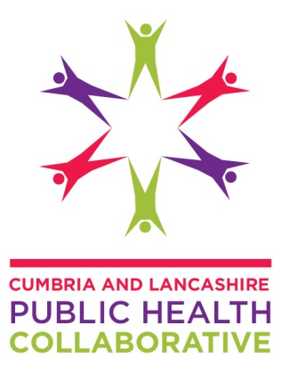
Tackle Cheap Alcohol with Minimum Unit Pricing
Burnley 3Tier Forum

- Purpose

To inform the Burnley 3 Tier Forum of the minimum unit pricing policy for alcohol and the impact of alcohol currently for Burnley.

- Background

The Cumbria and Lancashire Public Health Collaborative and DrinkWise organised an event on 20 November 2013 during Alcohol Awareness Week. At this event, stakeholders heard evidence from Sheffield's Alcohol Policy model and lessons learnt from Canada on minimum pricing for alcohol. Discussions at the event concluded that further awareness and engagement work was needed to develop a common understanding on the minimum unit pricing policy.

A project group has now been established to raise awareness on minimum unit pricing for alcohol by the Cumbria and Lancashire Public Health Collaborative, led by Dr Arif Rajpura, Director of Public Health at Blackpool Council.

Burnley 3Tier Forum has been identified as one of the key partners the project group would like to engage with. A factsheet has been produced by DrinkWise on the minimum unit pricing policy for alcohol, which also includes the impact of alcohol on Burnley and Lancashire (see attached).

- Feedback

The project group would welcome some feedback from the Burnley 3Tier Forum:

- Did you know about minimum unit pricing before this factsheet? (Yes/No)
- Are you now aware about minimum unit pricing after reading this factsheet? (Yes/No)
- Do you have any comments/suggestions for the project team to consider? Please give details

For further information about this programme, please contact:
Sangita Patel, Programme Manager, Cumbria and Lancashire Public Health Collaborative, sangita.patel@lancashire.gov.uk, 01772 536296

The Collaborative is a partnership between the Directors of Public Health from Blackpool Council, Blackburn with Darwen Council, Cumbria County Council and Lancashire County Council as well as other senior public health leaders.
DrinkWise is a member of the Alcohol Health Alliance, the national umbrella organisation which includes alcohol harm reduction charities, campaigners and health professionals.

